2024/06/17 Hora 16:14

Nivel_del_combustible



_2ea202d1-f685-4259-bceb-333fde3b0b2a.jpg

2024/06/17 Hora 16:36

2024/06/17 Hora 16:36

Nivel_del_combustible



_2ea202d1-f685-4259-bceb-333fde3b0b2a.jpg

2024/06/18 Hora 12:59

Nivel_del_combustible

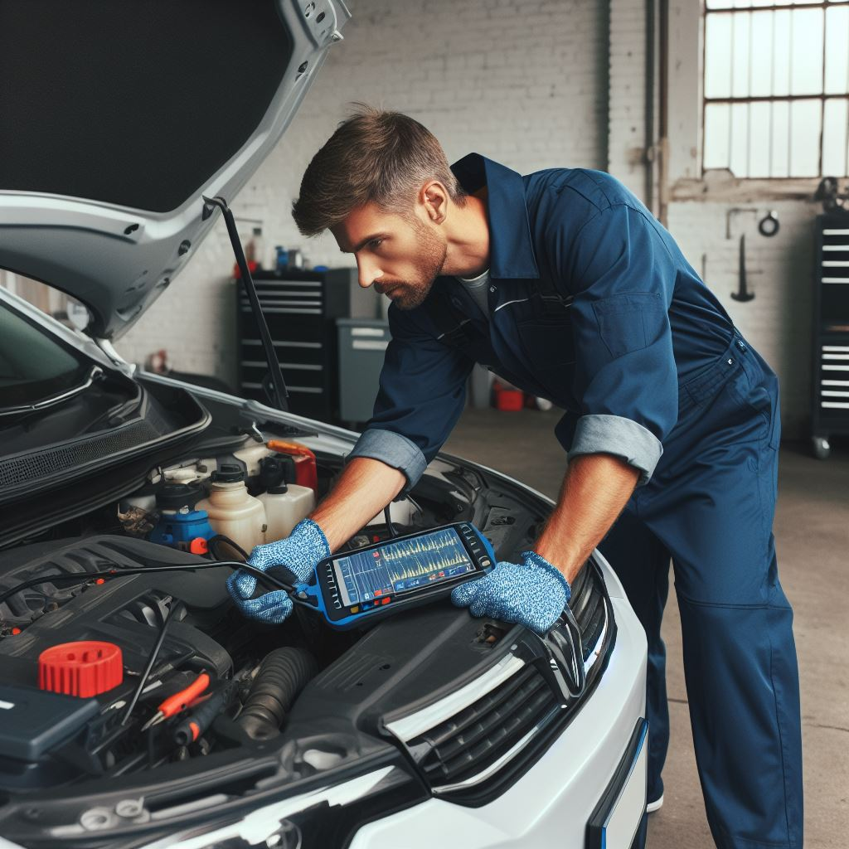

Inspeccion2.jfif

Nivel_del_combustible



Inspeccion2.jfif

Nivel_del_combustible



_2ea202d1-f685-4259-bceb-333fde3b0b2a.jpg

Nivel_del_combustible



_2ea202d1-f685-4259-bceb-333fde3b0b2a.jpg

Nivel_del_combustible



_2ea202d1-f685-4259-bceb-333fde3b0b2a.jpg

Nivel_del_combustible



_2ea202d1-f685-4259-bceb-333fde3b0b2a.jpg

Nivel_del_combustible



_2ea202d1-f685-4259-bceb-333fde3b0b2a.jpg